Forms Experts Program

Domain Name: Business Fulfillment Center (BFC) Requirements

Document Control Information

Document Information

|  |  |
| --- | --- |
| Document Name | Forms Experts Output_BFC Requirements |
| Document Author | Prashant Karande |
| Document Version | 1.0 |
| Date Released | 09/03/2013 |

Document Edit History

| Version | Date | Additions/Modifications | Prepared/Revised by |
| --- | --- | --- | --- |
| 1.0 | 09/03/2013 | Initial version | Prashant Karande |
|  |  |  |  |
|  |  |  |  |
|  |  |  |  |

Table of Contents

1. Functional Domain 4

2. Business Justification 4

Forms with FTS print job names include: 4

Forms with DMV print job names include: 4

3. List of forms covered under the domain 6

4. Analysis of Business Requirements 6

4.1 Common Requirements 6

4.2 State-specific Requirements (if any) 6

4.3 Related Change Requests (if any) 7

5. Key Understanding of Design requirements 7

5.1 880-618 CL story 7

5.1.1 System/UI Impact 7

5.1.2 Impacted Stories 7

880-618CL - Consolidated Form Content and Triggers - BFC Requirements and Print Jobs 7

5.1.3 Signature Rules (if any) 8

5.1.4 Document Content and Applicable Triggers 8

6 References to Documents 9

CR 0301 9

CR 0344 9

1. Functional Domain

Business Fulfillment Center (BFC) requirements act as enablers for the print job management team.

2. Business Justification

BFC Requirements help us to mainly manage the print jobs based on their triggers and queues. These print jobs makes it easy for Mail/Fulfillment to locate, print and mail the required documents. The PAS business analysts, fulfillment center team and the product team are involved in gathering the BFC requirements.

The purpose of FTS print job is to maintain consistency across all states and DMV print job for proper notifications. State specific BFC Requirements related to Packaging and Printing of forms will be captured in the state deltas. These deal with Billing, Printing and Document Creation areas.

FTS stands for Funds Transfer Scheme and DMV for Department of Motor Vehicles.

### Forms with FTS print job names include:

* NSF = Fee + Restriction (60 5000 AA)
* FNR = Fee + No restriction (60 5001 AA)
* CKRT = No fee + No restriction (60 5002 AA)
* Payment restriction (60 5003 AA)
* Remove recurring payments (60 5004 AA)
* Credit Card Exp Date (60 5006 AA)
* Unclaimed Search LTR (60 5010 AA)

### Forms with DMV print job names include:

* AASR22 - Financial Responsibility
* AASR26 - Cancellation of Financial Responsibility

The BFC requirements are captured in the BFC spreadsheet. This spreadsheet contains the following tabs:

1. Instructions tab
2. Tab A. Form Details
3. Tab B. Print Jobs
4. Tab C. Print Center Reports
5. Tab D. Container Reqs.
6. Tab E. IMB
7. Tab F. 2D Specifications
8. Tab G. Runbooks
9. Tab H. E-Signature Candidates

### Forms details

This tab has information about the forms applicable for the state. It contains the following details:

* FORM TITLE
* FORM NUMBER
* STATE
* TRIGGER
* PRINT JOB NAME
* PAPER TYPE
* HAS ADDRESS BLOCK (Y/N)
* INCLUDE REMIT ENV. (Y/N)

Based on the trigger the forms are assigned to print jobs. These print jobs are associated with the print queues where the documents are sent for printing. The documents are picked for processing from the print queues

### Print Jobs

This tab lists out all the available print job names. These print jobs are mapped to the transactions/ triggers.

| PRINT JOB NAME | TRANSACTION TYPE |
| --- | --- |
| X_AU_ID_Canc_ | Cancellation |
| X_AU_ID_NonRen_ | NonRenewal |
| X_AU_ID_RefChk_ | Refund check |
| X_AU_ID_Bill_ | Billing |
| X_AU_ID_Misc_ | Miscellaneous |
| X_AU_ID_AMD_ | Amended |
| X_AU_ID_NB_ | New Business |
| X_AU_ID_REN_ | Renewals |
| X_AU_ID_LAPS_ | Lapse notice |
| X_AU_ID_REN-OFlow_ | Renewals 11+ PAGES |
| X_AU_ID_NB-OFlow_ | New Business 11+ PAGES |
| X_AU_ID_AMD-OFlow_ | Amended 11+ PAGES |
| X_AU_ID_Misc-OFlow_ | Miscellaneous 11+ PAGES |
| X_AU_AA_FTS | FTS forms (CR in progress) |
| X_AU_ID_DMV | DMV transactions |
| X_AU_ID_Rein | Reinstatement |

### Print center Reports

These list out the reports and the fields that will be displayed per the reports. There are some sample reports attached in this tab.

The following is the list of reports:

1. Barcode Station Reports
2. Policy Divert Detail Report
3. Non Payment Cancellations Proof of Mailing Report
4. Non Renewals Proof of Mailing Report
5. Check Reconciliation Report

### Container Reqs.

This tab contains information for implementation of miscellaneous requirements for BFC/production. This includes placement of address block, barcode, perforation, remittance address, scan line and and creation of envelope

### IMB

This tab contains all the information required for IMB – Intelligent Mail Barcode. It has specifications for how the barcode is generated.

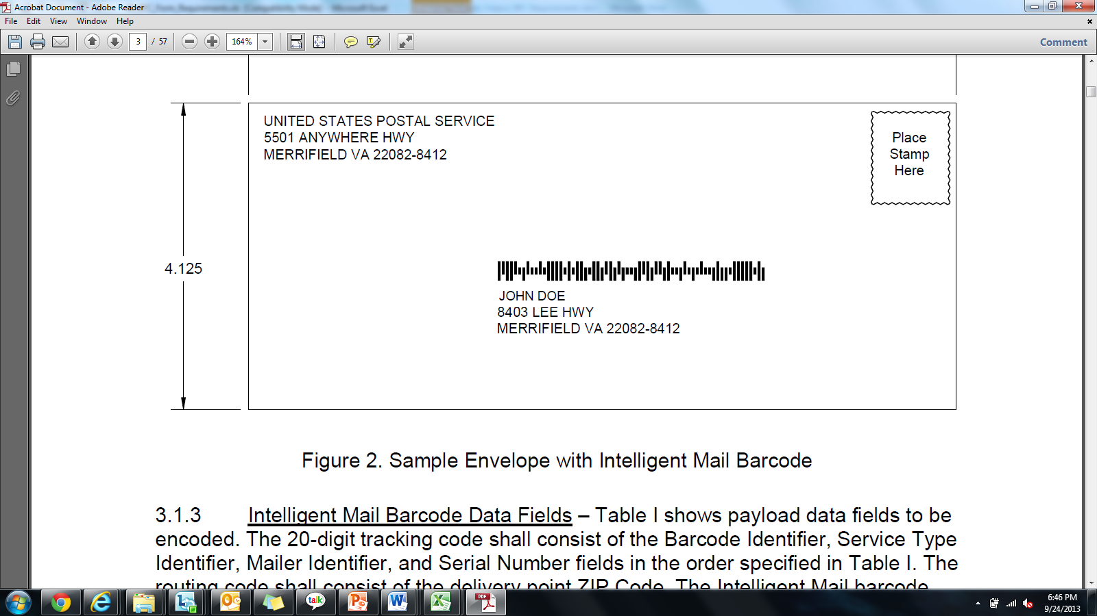

Figure: Sample envelope with IMB

### 2D Specification

This tab has the information about the specifications for each character displayed in the 2D barcode which is placed at the top left corner of forms.



Figure: Sample specifications for Character 1

### Runbook

Runbook consists of the information batch of copies printed. Runbook is maintained as a log for all the documents being printed.

### E-Signature Candidates

This tab consists of information for the forms where e-signature is applicable.

3. List of forms covered under the domain

N/A

4. Analysis of Business Requirements

## Common Requirements

N/A

## State-specific Requirements (if any)

N/A

## Related Change Requests (if any)

| CR No. | CR Name | States Impacted | CR Description and its Business Use |
| --- | --- | --- | --- |
| CR0301 | BFC and print job requirements for documents | All States | * Missed requirements. Business Fulfillment Center (BFC) requirements have not been captured/ documented for any given state so far |
| CR0344 | Billing Forms 60 5000 - 60 5004 | CL | * This CR includes the removal of the existing CA forms, replacing them with the forms listed above and the two CR0059 forms (60 5005 and 60 5006) * The CA forms to be replaced and with the new FTS forms |

5. Key Understanding of Design requirements

* 1. **880-618 CL story**

### System/UI Impact

| Page | Yes/No | Page Section |
| --- | --- | --- |
| Forms | | No | N/A | |
| Documents | | No | N/A | |
| GODD | | No | N/A | |
| Related UW Rule/Task | | No | N/A | |

### Impacted Stories

| Type | Story # |
| --- | --- |
| Form Content & Triggers | 880-618CL - Consolidated Form Content and Triggers - BFC Requirements and Print Jobs |
| Documents Page | N/A |
| GODD Page | N/A |
| Forms Page | N/A |
| RFI | N/A |
| Packet/Print Story | N/A |

### Signature Rules (if any)

* N/A

### Document Content and Applicable Triggers

* 880-618CL
  + Consolidated Form Content and Triggers - BFC Requirements and Print Jobs
    1. **Key pointers to keep in mind**

## For design requirements, the scope of BA team is only to list all the forms that are applicable for the state. This would include all the CL forms and state specific forms/ documents

## The best reference documents to be used for this exercise are:

## printing order document (for triggers)

## B_PAS document for all forms (state and CL)

## The trigger requirements should also be cross checked through individual form requirements

## The Test package for 880-618 consist of majority of forms except the ones that are covered in the test package for packet story (880-880)

# References to Documents

| Document Name | Document Description |
| --- | --- |
| [CR 0301](https://ekm1.stage.exigengroup.com/EKMWiki/index.php/CR0301_-_BFC_Requirements) | Link for CR 0301 Assessment document |
| [CR 0344](https://ekm1.stage.exigengroup.com/EKMWiki/index.php/CR0344_-_FTS_Forms_60_5000_-_60_5001_-_60_5002_-_60_5003_-_60_5004) | Link for CR 0344 Assessment document |
| [ID BFC](https://ekm1.stage.exigengroup.com/EKMWiki/index.php/880-618ID_-_BFC_Requirements_and_Print_Jobs) | Link for sample Idaho BFC spreadsheet |

About Deloitte

Deloitte provides audit, tax, consulting, and financial advisory services to public and private clients spanning multiple industries. With a globally connected network of member firms in 140 countries, Deloitte brings world-class capabilities and deep local expertise to help clients succeed wherever they operate. Deloitte's 165,000 professionals are committed to becoming the standard of excellence.

Deloitte's professionals are unified by a collaborative culture that fosters integrity, outstanding value to markets and clients, commitment to each other, and strength from cultural diversity. They enjoy an environment of continuous learning, challenging experiences, and enriching career opportunities. Deloitte's professionals are dedicated to strengthening corporate responsibility, building public trust, and making a positive impact in their communities.

Deloitte refers to one or more of Deloitte Touche Tohmatsu, a Swiss Verein, and its network of member firms, each of which is a legally separate and independent entity. Please see www.deloitte.com/about for a detailed description of the legal structure of Deloitte Touche Tohmatsu and its member firms. Please see <http://www.deloitte.com/us/about> for a detailed description of the legal structure of Deloitte LLP and its subsidiaries.

Internal Usage Statement

This publication is for internal distribution and use only among personnel of Deloitte Touche Tohmatsu, its member firms, and its and their affiliates. Deloitte Touche Tohmatsu, its member firms, and its and their affiliates shall not be responsible for any loss whatsoever sustained by any person who relies on this publication.

Copyright © 2013 Deloitte Development LLC. All rights reserved.

Member of Deloitte Touche Tohmatsu